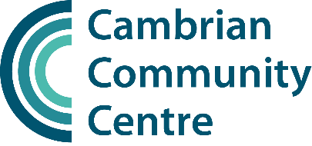

Part Time Gym Instructor
4 hours a week, 9am – 1pm Saturdays
Cambrian Community Gym – Richmond
Hourly rate £14.95

The Cambrian Community Gym is a small friendly community facility which forms part of the Cambrian Community Centre, located in Richmond, South West London. It is a charitable, not-for-profit organisation focussed on improving health and wellbeing.

We provide tailored gym programmes for our largely older clientele, many of whom have been referred by health professionals for rehabilitation exercise programmes following a medical condition or accident.

We are looking for a caring and professional individual to join our small team of gym instructors working 4 hours on Saturdays, 9am -1pm. You may also be asked to cover weekday shifts to cover staff holidays etc.

Your skills/experience:

As a minimum, you will have a gym instructor qualification, an exercise referral qualification and some previous experience in a gym environment. In addition any of the following would be an advantage:

- A recognised Level 3 Personal Trainer qualification
- A Sport Rehabilitation or Physiotherapy degree or other relevant degree level qualification
- Cardiac Phase IV rehabilitation qualification
- Significant previous experience in a gym
- Experience of working with older people and people with health issues.

What the role involves:

You will be responsible for overseeing the operation of the gym and engaging with gym users to support and encourage them to pursue their exercise objectives. You will:

- undertake inductions and ongoing assessment of exercise programmes and support and encourage users in their exercise programmes and objectives
- uphold the highest standards of hygiene, keeping the gym clean and tidy at all times
- ensure safe behaviours at the gym and appropriate use of equipment
- contribute to the gym team and the wider Community Centre – including attending team meetings and the Charity’s annual general meeting
- maintain gym and user records, take payments and other admin to ensure the effective operation of the gym

You must be comfortable working independently, using your initiative as well as being part of the wider team.

Renumeration:

In return for your hard work, we offer:

- Contracted salary at an hourly rate of £14.95
- 4 hours contracted per week
- Pro-rated annual leave entitlement
- Funded First Aid qualification updates and other training opportunities

If you have a passion for improving lives through exercise, and want to make a difference supporting an older client group improve their fitness and capabilities, then the Cambrian Community Centre Gym is the place for you.

If you are interested in this role please complete the application form and return it to David Lemon, Community Centre Manager, at manager@cambriancentre.org.

November 2025

